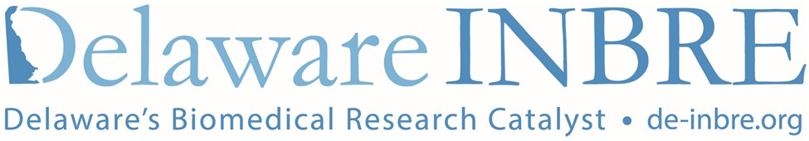

Delaware INBRE Student News
National Institutes of Health (NIH-NIGMS) INBRE (IDeA Network of Biomedical Research Excellence) program
Return this form and all accompanying documents to either address:
Email: inbre-education@udel.edu
Mail: Delaware INBRE, Linda Polasko, STAR Annex, 540 South College Ave, Newark, DE 19713

Contact Information:
Last name | First name |  | MI
University | Email

When were you an INBRE Scholar?

Where were you an INBRE Scholar?

Who was your mentor?

Please check type of activity:
___ Publication - paper (provide citation)
___ Publication - abstract (provide citation)
___ Presentation – oral/podium
(provide title of talk, name of presenter, authors, name of meeting, dates, location)
___ Presentation – poster (provide title of poster, authors, name of meeting, dates, location)
___ Recognition – award (name of award, brief description of award, awarding agency name)
___ Attendance at national or international association meeting using INBRE funds or connections
(provide name of meeting, hosting INBRE institution, dates of meeting, location)
___ Events sponsored by INBRE attended
(name of event, location, dates, sponsoring INBRE institution)
___ Other – describe:

News Update:

